KASHIPUR MICHEAL MADHUSUDAN MAHAVIDYALAYA
(PERSONAL PROFILE)
Name: Dines Chandra Maiti
Designation: Librarian
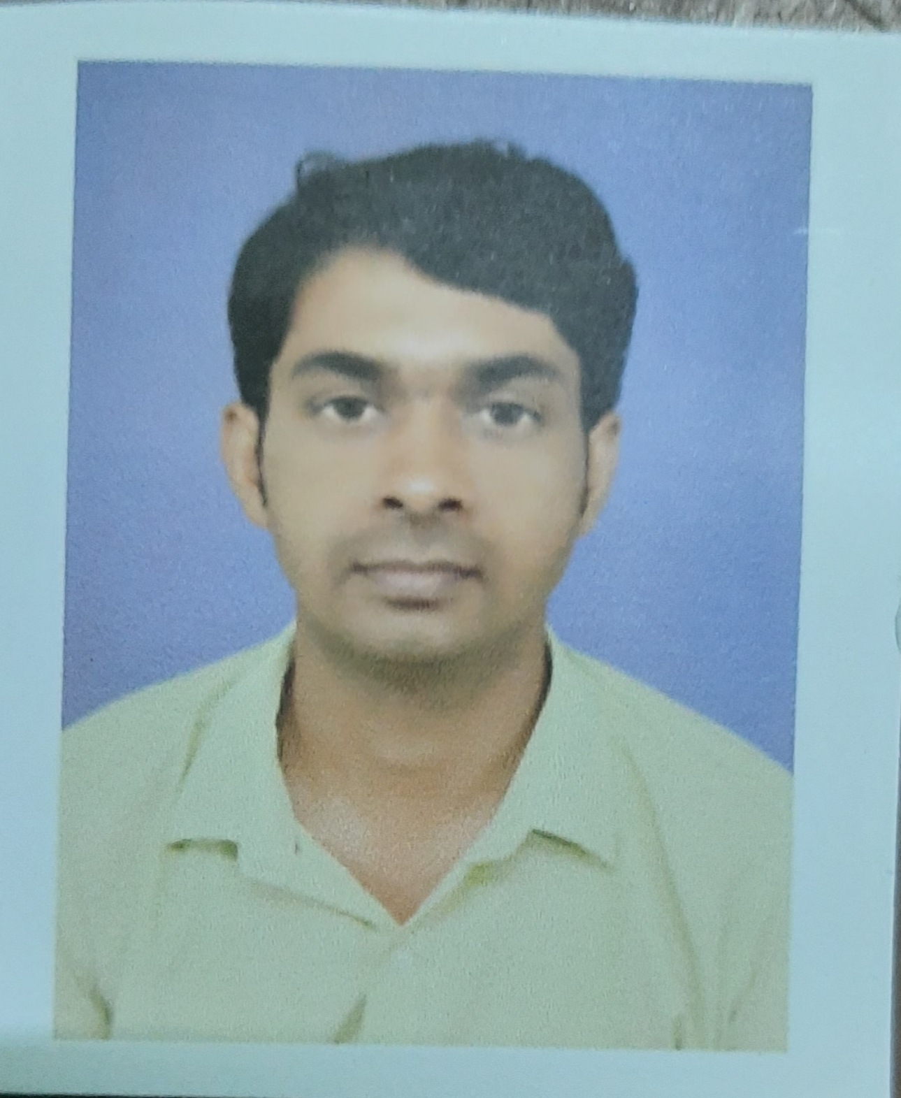
Date of Joining: 22.12.2016
e-mail: dines.maiti@gmail.com
Educational Qualification:
- Graduation: B.A HONs.
- Post-graduation: MLISc
Publication Details
Conference/Symposium/Journal Paper Published:
Title | Published in | Year | Published by
Comparative Study between words in titles and Kyewords of some articles on Knowledge organization | DESIDOC Journal of Library & Information Technology, 33 (6), p. 498-508 | 2013 | Defence Science Information and Documentation Centre, DRDO
Department wise citation and h-index analysis of IIT Kharagpur during 2010-2014 | International Journal of Innovative Knowledge Concepts, 1(2), p. 52-62 | 2015 | IJIKC , Pune
Library use skills among PG & Ph.D students of Pondicherry University : a survey | International Journal of Next Generation Library and Technologies, 1(4) | 2015 | IJNGLT, Chennai
Is There Any Need Of Public Library For Transgender People? | Knowledge Librarian, 5(6), p. 20-25 | 2018 | Knowledge Publishing, Printing and Distribution House, Aurangabad  Maharashtra

Conference/ Seminar attended and Paper Presentation:
Title of the Conference/Seminar | Level | Year | Role | Held at and Organiser
College Libraries Today and Tagorean Concept of Library |  | 2011 | Attended | Narajole Raj College, Paschim Medinipur on February 24-25, 2011
Digital Future of Library Materials: Issues & Challenges |  | 2011 | Attended | Dept. of Library and Information science, Vidyasagar University, Midnapore on March 17-18, 2011
Glorious 100 years of LIS Education in India: Introspect & prospects | International | 2011 | Paper Presenter(LIS Education in India) | Dept. of Library and Information science, Vidyasagar University, Midnapore on December 8-9, 2011
Tagorean Concept on Library Activities & Services |  | 2011 | Attended | Central Library, K.D.College of Commerce and General Studies, Medinipur on December 16-17, 2011
Maulana Abul Kalam Azad: a Scholar and National Leader |  | 2012 | Attended | Narajole Raj College, Paschim Medinipur on March 20-21, 2012
UGC Sponsored Tow Days National Seminar on Bonding of people’s Knowledge and People’s University: Pre-requisites of Knowledge Economy | National | 2017 | Paper Presenter (Empowerment of Women through Public Library) | Dept. of Library and Information science, Vidyasagar University, Midnapore on March 23-24, 2017
Role of Public library in Archiving the Cultural Heritage of Bengal |  | 2018 | Paper Presenter (What Public Library can do for Transgender People in Educating them) | Central Library, Tamralipta Mahavidyalaya, Purba Medinipur on January 09-10, 2018
The Symbiotic Reciprocation between School Library and Public Library: Rejuvenation of People’s University in Knowledge Society |  | 2018 | Paper Presenter (Trend of Public Library Research in India: a Bibliometric Study) | Dept. of Library and Information science, Vidyasagar University, Midnapore on March 22-23, 2018
Bhadu & Traditional Vadra-Culture | International | 2018 | Participated | Dept. of Bhadu, Kashipur M.M.M., Purulia on 14th September, 2020
International Conference on Marching Beyond the Libraries: Managerial Skills & Technological Competencies | International | 2018 | Paper Presenter (Library Science Reseach Trend in India) Book Published with ISBN | Central Library, KIIT Deemed to be University, Bhubaneswar on November 16-17, 2018
Media, Society and Culture: Interrelations and Changing Scenario | International | 2020 | Participated | Dept. of Sociology, Kashipur M.M.M., Purulia February 25-26, 2020
COVID – 19: Challenges and Opportunities | WEBINAR | 2020 | Participated | Kashipur Michael Madhusudan Mahavidyalaya, Purulia on 5th June, 2020
Installation and Customization of Koha: A Beginner’s Approach | WEBINAR | 2020 | Participated | Bengal Library Association, Kolkata on 27th June, 2020
Access of Library Learning Resources in Digital Format | National  WEBINAR | 2021 | Participated | Panchmura Mahavidyalaya, Bankura on 13th June, 2021
Library & Information Science: The Career Prospects for Under Graduate Students | National  WEBINAR | 2021 | Participated | Central Library, SKBU, Purulia on 16th August, 2021
Sadharan Granthagar Byabaster Punarujjibane Janasadharaner Bhumika | State  WEBINAR | 2022 | Participated | Bengal Library Association, Paschim Medinipur District Committee on 15th January, 2022
Vidyasagar’s Thought on Books & Library (Vidyasagarer Grantha O Granthagar Bhabna) | State | 2023 | Paper Presenter (Female Literature in West Bengal During and After Vidyasagar Period: Historical Study) | Entral Library, K D College of Commerce & General Studies on 20th December, 2023

Workshops Attended:
- Half Day Workshop On "TURNITIN ANTI-PLAGIARISM WEB TOOL" Organized by the Central Library, IIT Kharagpur on 8th January, 2014.
- The National workshop on “Web Scale Discovery Services Single Window Access to Library e-Resources” Organized by the Central Library, IIT Kharagpur on 10th January, 2014.
- Five Days National Workshop on “Use of Open Source Library Management Software KOHA” organized by the Library Documentation & Inf. Sci. Div., Indian Statistical Institute, Kolkata during 5-9 October 2015.
- “One-Week Capacity Building Programme for the Information Professionals”organized by the Department of Library and Information Science, Vidyasagar University. In collaboration with Internal Quality Assurance Cell (IQAC) Vidyasagar UniversityMidnapore – 721 102, West Bengal, during August 26, 2022 - September 1, 2022.

Awards and Recognition:

Areas of Specialization in Research / Teaching:
- Specialization in Teaching:Knowledge Organization

- In Research:Colon Classification

Teaching:
- Theory:
- Practical:
- Excursion / Field Survey:

Invited Lecture / Foreign Visit:
1.

Other Academic Activities:

- Board of Studies:
- Course Design:
- Paper Setter:

Administrative Activities:

1.

Associated with Learned Bodies / Association / Society / Organization:

1. Indian Library Association, Delhi

OP & RC:

1.RC: Participated in the online Refresher Course in Library and Information Science in the proctored examination held on 30.03.2019 through SWAYAM platform offered by IGNOU.
2. OP (FIP): Participated in the online Faculty Induction Programme from 26.11.2020 to 23.12.2020 at UGC HRDC, Ranchi University.
3. RC: Participated in the online Refresher Course in Library and Information Science heldfrom 07.10.2022 to 20.10.2022 at UGC HRDC, Mizoram University.

